27-05-2025(MONGODB)

**NAME:** Ch.Eswara Balaji

1)Available databases

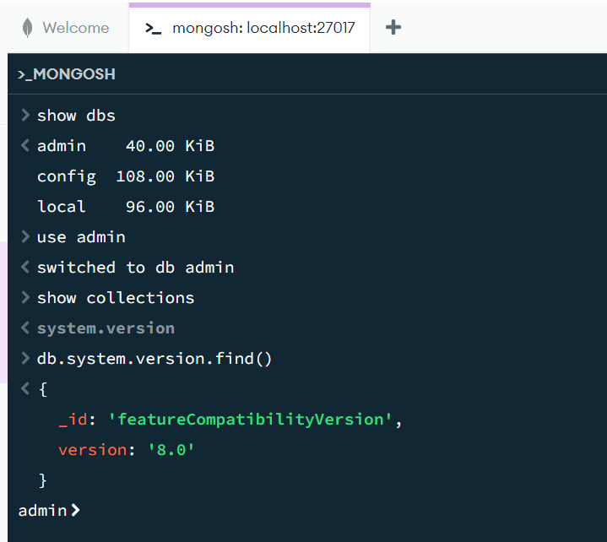

2)Adding database

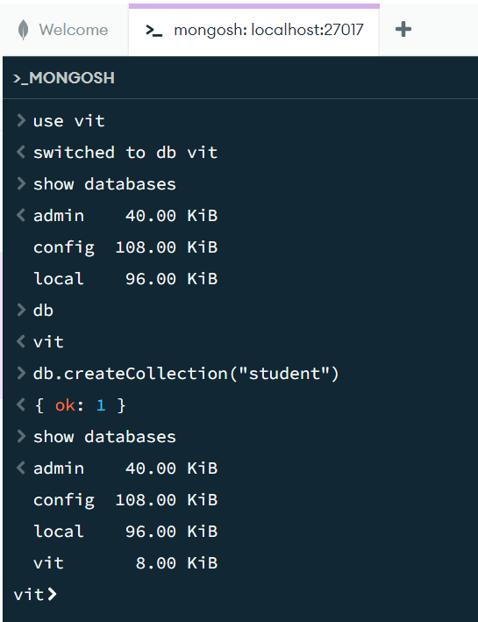

3)Droping the collections

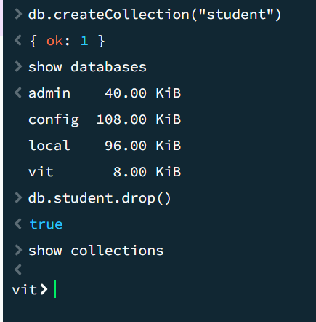

4)Inserting the single data into vit dbs collections

